Anna Oleksyeyenko

W1627858

CISP 350 Th 5:30

Assignment #8 – Database Foundations 6-8

Database Foundations 6-8 : Sorting Data Using ORDER BY

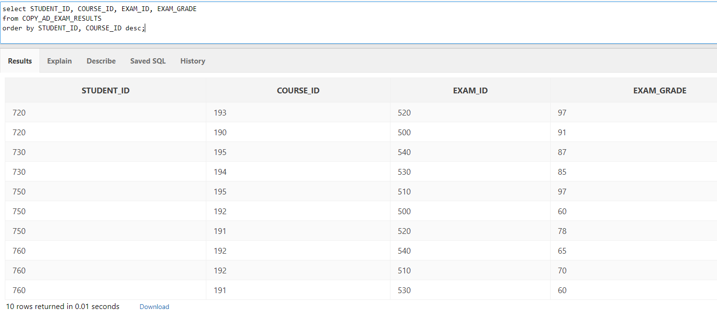

select STUDENT_ID, COURSE_ID, EXAM_ID, EXAM_GRADE

from COPY_AD_EXAM_RESULTS

order by STUDENT_ID, COURSE_ID desc;

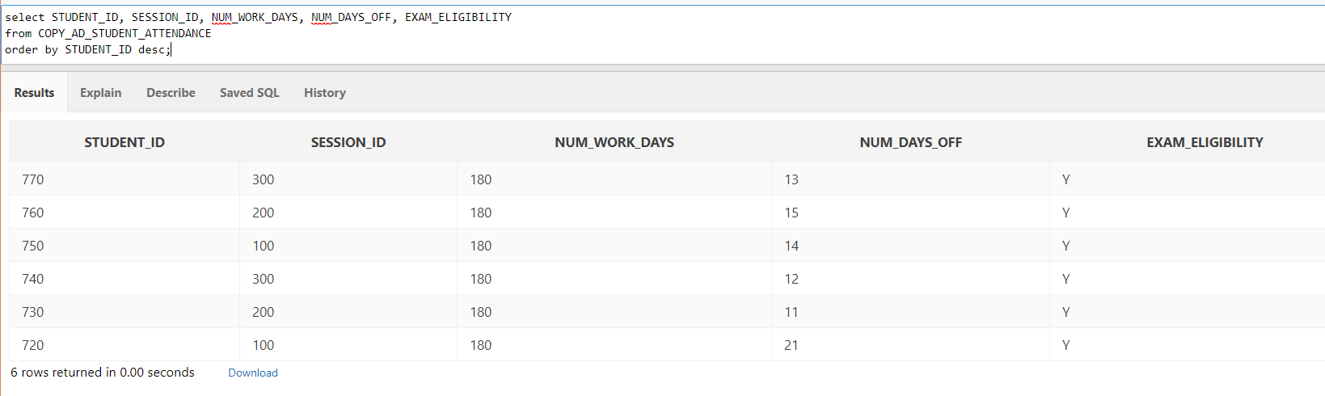

select STUDENT_ID, SESSION_ID, NUM_WORK_DAYS, NUM_DAYS_OFF, EXAM_ELIGIBILITY

from COPY_AD_STUDENT_ATTENDANCE

order by STUDENT_ID desc;

select * ROWNUM AS "TOP 5 STUDENTS" STUDENT_ID, COURSE_ID, EXAM_ID, EXAM_GRADE

from

(select * from COPY_AD_EXAM_RESULTS

order by EXAM_GRADE)

where ROWNUM >=70;